7

Struts View Components
This chapter introduces the components that make up the view portion of the Struts framework. The framework uses the view components to render dynamic content for the client. Based primarily on JavaServer Pages, the components provide support for internationalized applications, as well extensive support for user input acceptance, validation, and error handling, all of which make it easier for the developer to focus on business requirements. This chapter concludes the three-part discussion of how the Struts framework implements the MVC pattern.
This chapter will also briefly discusses the up and coming JavaServer Faces specification. Although still in early draft, it appears that this specification will impact the Struts framework in the future.

What exactly is a View?
In a general sense, the view represents a display of the domain model in a UI. There doesn’t have to be just a single view of the model, there can actually be many different ways to represent the same model. As you learned in Chapter 5, the domain model contains the business entities, which hold state for the application. Metaphorically speaking, a view is a window that clients can use to peek at the state of the model. The perspective may be different depending on which window a client looks through. For example, in the Storefront application, the front page shows a set of featured items in the catalog. It doesn’t show all of the information about each item, only a small portion. This “summary” view is used in the Storefront application where real estate is scarce as in the first page. Figure 7-1 shows the main page of the Storefront application.
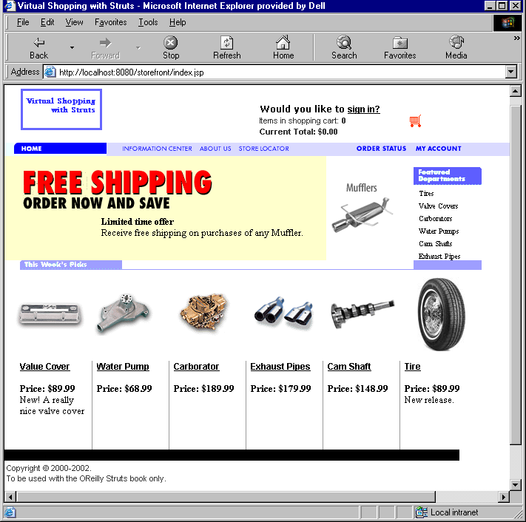
Figure 7-1. The Storefront Main Page is One Perspective of the Model
When a user selects one of the items for sale, all of the details of the item are displayed. The user is still looking at the same business model, but the view is different. This alternate view of the model is shown in Figure 7-2.
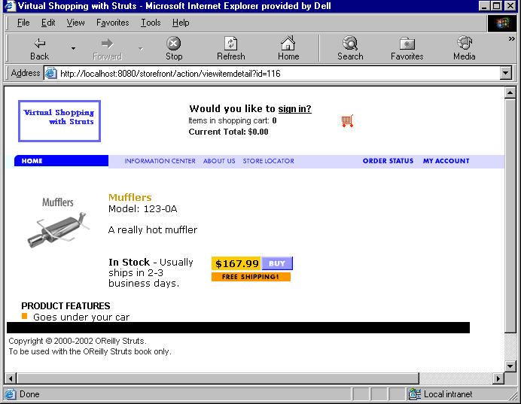
Figure 7-2. An Alternate View of the Storefront Model
A more detailed view of the business model is necessary for this page. There may be different JSP pages, images, multimedia files, and other view related components. These two different perspectives are in fact two different views of the same model.
Because business objects don’t have a natural way of representing themselves externally, it’s up to the view components to present the domain model information to the clients. This presentation may be in the form of XSLT and XML, Simple Object Access Protocol (SOAP) messages returned to a web service client, or in the case of the Storefront application, HTML rendered in a browser. In any case, the model is used to represent the state of the application, while the views are used to present the model, or a portion of it, to the client.
It wouldn’t be hard to imagine a different type of client, a wireless device for example, looking at a completely different set of views, but still using the same model. Although the Storefront application shown throughout this book is geared towards B2C, it’s possible to have a B2B application using the same model to make part ordering functionality available to partners. As long as the proper separation is maintained between the model and the presentation layer, you can build any number of views for any number of clients on top of the same domain model.

Using Views within the Struts Framework
Generally speaking, the views in the Struts framework are built using JSP pages. Other presentation technologies can be used, but JSP is widely used within the Struts community. The JSP technology is a very popular choice for generating dynamic content using the Java language. There are other approaches and frameworks available for performing the same behavior. The alternatives will be discussed in Chapter 16 Using Alternate Presentation Technologies.
Although JSP pages are the main components used by most Struts applications to render the views, there are additional components that can be used by or in conjunction with the JSP pages.
- HTML Documents
- JSP Custom Tag Libraries
- JavaScript and Style Sheets
- Multimedia Files
- Message Bundles
- ActionForm Classes

HTML Documents
Although HTML documents are only able to generate static content, there’s nothing wrong with using standard HTML documents within your Struts applications. Obviously they are unable to render any dynamic data, but they are still valid to use whenever the view is static and you don’t need the dynamic capabilities of JSP.
For example, a login page may just be an ordinary HTML document that invokes a Struts login Action. To take advantage of many of the automatic features of the Struts framework, especially ones related to custom tags, you would need to utilize JSP instead of straight HTML.

JSP Custom Tags
The JSP custom tags can play a very important role within a Struts application. Although an application is not required to use them, in some particular scenarios, it would be very difficult without them. In future version of the framework, they will maintain their importance, but the framework will make it easier to use alternate strategies.

JavaScript and Style Sheets
The Struts framework doesn’t prevent you from using JavaScript within an application. On the contrary, it provides functionality within the tag libraries to help facilitate using JavaScript. The JavaScript support within custom tags will be discussed in Chapters 8.
Style sheets are used to help web designers gain more control over the appearance of a web site. Features such as character size, color, font, and other look and feel characteristics can be changed in a central location and will have an immediate effect throughout the entire site.
The Struts framework does not prevent you from using style sheets. Just like with standard HTML files, you can include style sheets in the JSP page and it will be rendered on the browser just as they would be for standard HTML pages.

Multimedia Files
Multimedia files are used in just about every web application. These include but are not limited to:
- Images (.gif, .jpg, etc.)
- Audio (.wav, .mp3, etc.)
- Video (.avi, .mpg, etc.)
Images are probably the most widely used, although for B2B applications, audio and video files are also prevalent. The Struts framework supports using multimedia files within an application. The support is achieved mainly through the use of custom tags, but you are also free to use standard HTML to render these types of resources.
There are a few sore spots when it comes to rendering images using the custom tags. It mainly has to do with the differences between absolute and relative associations. These issues however, are more related to web applications in general, rather than a particular issue within the Struts framework.

Message Bundles
The message resources, or resource bundles as they are commonly referred, are a very important component for Struts applications. Not only do they provide a means to support localization, but they also help to reduce maintenance time and redundancy throughout an application.
For example, suppose your web application uses certain text labels or messages in multiple locations. Instead of hard-coding the string in every page, you can specify it in the bundle and retrieve it using one of the custom tags. Then if the text label or message needs to change, only the one in the bundle needs to be modified. This helps to reduce maintenance time because it only needs to be changed in one location.
Some might consider the resource bundles belonging to the model, rather than the view. However, because the bundle also contains labels and strings for such things as text fields and checkbox labels, page titles, and so on, a valid argument can be made either way.

Using JavaBeans within the View Components
It might seem weird to talk about JavaBeans within a chapter on views. However, since JavaBeans make up a large portion of how the model data is used within the framework, it makes sense to briefly discuss them.

JavaBean Quick Refresher
JavaBeans itself is a portable, platform independent component model written in the Java programming language. The JavaBeans component architecture allows developers to create reusable components that can be used on any platform that supports a JVM. The JavaBeans model supports properties, events, methods, and persistence.
The extent to which the Struts framework and Java web applications in general, utilize JavaBeans is much less than what’s described by the JavaBeans specification. They are used much more like ordinary Java objects, however they must follow certain guidelines for them to be useful in Struts applications:
- Must provide a zero-argument constructor
- Should provide both a get<PropertyName> and set<PropertyName> method for all properties defined within the bean
- For boolean properties, if the method is<PropertyName> is present, it will be used to read the property value
- For indexed properties where there is a property defined like <PropertyElement>[], then the methods get<PropertyName>(int a) and set<PropertyName>(int a, PropertyElement b) should be present
These guidelines are necessary for the beans to be introspected at runtime by the framework.
One of the common traps that Struts developers fall into when dealing with JavaBeans is to use a different return type from the parameter type. If you create a method in a JavaBean that passes a String as an argument:
public void setDescription( String newDescription );
then you must have a corresponding get method that returns the same type:
public String getDescription();
If the return type differs from the parameter type, the Struts framework may not recognize it as a bean and you will likely get an error message stating that “No getter method could be found” or “No setter method could be found” for the property name.

How are JavaBeans used by Struts Applications?
In a strict MVC architecture, the view gets updates directly from the model when it receives a notification that something has changed within the model. Figure 7-3 shows a diagram illustrating this.
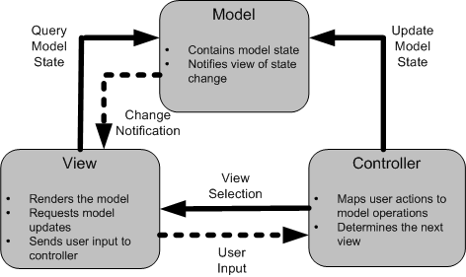
Figure 7-3. The view queries the model for state information
With web applications, this notification is not possible, or at least is difficult to achieve. Normally, it’s up to the client to issue a request to the controller to refresh a view from the model state. It’s up to the client to “pull” the view from the model, instead of the model “pushing” changes out to the view.

The Data Transfer Object Pattern
Chapter 6 discussed one approach to building the model components for a Struts application. The one thing that was left intentionally out until now is exactly how the view accesses the data from the model. To understand this, it will help to understand the Data Transfer Object pattern.
The Data Transfer Object (DTO) pattern is used quite frequently in J2EE applications, where distributed components making remote calls can suffer serious performance impacts from using too remote invocations. It also has been used in other technologies as well, but under different names and disguises.
In some software literature, it is also referred to as the Value Object or Replicate Object pattern.
A DTO is a course-grained view of what is typically fine-grained information. It aggregates various attributes from one or more business entities and puts this information into a JavaBean instance. This instance can then be passed throughout the local application, or even serialized and sent over the network, and clients can retrieve the model information from a local object and not suffer any negative performance impact.
The DTO doesn’t normally provide any business logic or validation, but does provide access to the properties of the bean. Some documentation on this pattern suggests that the bean should be immutable to help reinforce that the object is local and changes will not be reflected in the system. However, this can cause problems because the JavaBean specification requires that all private properties have a getXXX and setXXX method. It is up to you to determine how best to handle the mutability of DTOs based on your requirements.
DTOs are effectively part of the model, since they are just local, possibly immutable copies of the business objects. Within Struts applications, they are used by the view to deliver the model data that is rendered along with the static information in the page.

What are ActionForms?
Almost every web application has a requirement to accept input from users. Some examples of user input are credit card information, billing and shipping address information, or even something as small as a username and password. The HTML language provides the necessary components to render the input fields in a browser, including text boxes, radio buttons, check boxes, buttons, and many more. When building these types of pages, the input components must be nested inside of an HTML form element. Example 7-1 illustrates a very basic Signin page similar to the one used in the Storefront application.
Example 7-1. Form fields must be nested inside of a form element
<html>
<title>Example 7-1. OReilly Struts Book</title>
<link rel="stylesheet" href="stylesheets/main.css" type="text/css">
</head>

<body>

<form method="post" action="/action/signin">

<!-- The Table layout for the email and password fields -->
<table BORDER="0" cellspacing="0" cellpadding="0">
<tr>
<td>Email: </td>
<td>&nbsp; </td>
<td>
<input type="text" name="email" size="20" maxlength="20"/>
</td>
</tr>

<tr>
<td>Password:</td>
<td>&nbsp; </td>
<td class="alignformslist">
<input type="text" name="password" size="20" maxlength="25"/>
</td>
</tr>

<!-- The Table layout for the signin button -->
<table width="250" border="0">
<tr>
<td>
<input type="submit" name="Submit" value="Signin" class="Buttons">
</td>
</tr>
</table>
</form>
</body>
</html>
When the user presses the Signin button on the HTML form from Example 7-1, the values within the fields are submitted along with the HTTP request. The server application can retrieve the values that were entered, perform input validation on the data, and then pass the data to another component in the application where the actual authentication process can occur. If the input data fails the input validation rules, the application should return back to the previous location, redisplay some or all of the values entered, and display an error message that the login attempt failed.
Performing all of this functionality manually, retrieving the values, executing the validation, returning back and displaying error messages on a failure, can be a daunting task. This type of behavior is typically performed in many places throughout a web application. It would be nice to have this functionality taken care of for you by the framework and be able to reuse it across applications.
Fortunately, the Struts framework does provide this functionality and will handle these tasks on behalf of your application. The Struts framework relies on the org.apache.struts.action.ActionForm class as the key component for handling these tasks.
The ActionForm class is used to capture input data from an HTML form and transfer it to the Action class. Since the HTML input components don’t natively include an input buffer and users quite often enter invalid data, web applications need a way to store the input data temporarily, so that it can be redisplayed when an error occurs. In this sense, the ActionForm class acts as a buffer to hold the state of what the user entered while it is being validated. The ActionForm also acts as a “firewall” for your application in that it helps to keep suspect or invalid input out of your business tier until it can be scrutinized by the validation rules. Finally, the ActionForm is also used to transfer data from the Action class back to the HTML form. This allows more consistency for your HTML forms, because they are always pulling data from the ActionForm.
When the user input data does pass input validation, the ActionForm is passed into the execute() method of the Action class. From there, the data can be retrieved from the ActionForm and passed on to the business tier.
Because the ActionForm imports packages from the Servlet API, you shouldn’t pass the ActionForm to the business tier. Doing so would couple the business methods to the Servlet API and make it more difficult to reuse the business tier components. Instead, the data within the ActionForm should be transferred to an object from the domain model instead of being passed as an argument to the business tier. A common approach is to create a data transfer object and populate it with the data from the ActionForm.
You don’t have to declare an ActionForm for every HTML form in your application. The same ActionForm can be associated with one or more action mappings. This means that they can be shared across multiple HTML forms. For example, if you had a wizard interface, where a set of data was entered and posted across multiple pages, a single ActionForm can be used to capture all of this data, a few fields at a time.

ActionForms and Scope
ActionForms can have two different levels of scope, request and session. If request scope is used, an ActionForm will only be available until the end of the request/response cycle. Once the response has been returned to the client, the ActionForm and the data within it is no longer accessible.
If you need to keep the form data around longer than the request, you can configure an ActionForm to have session scope. This might be necessary if your application captures data across multiple pages, similar to a wizard dialog. An ActionForm that has been configured with session scope will remain in the session until it’s removed, replaced with another object, or until the session times out. The framework doesn’t have a built-in facility for cleaning up session scoped ActionForm objects automatically. Like any other object placed into the HttpSession, it’s up to the application to routinely perform clean up on the resources stored there. This is slightly different from objects placed into the request, because once the request is finished, they can be reclaimed by the garbage collector since they can no longer be referenced.
Unless you need to specifically hold the form data across multiple requests, you should use request scope for your ActionForm objects.
If you don’t specify the scope attribute for an action mapping, the ActionForm will default to session scope. To be safe, you should always explicitly specify the scope of the ActionForm. To see how to specify the scope for an action element, see “The Struts Configuration DTD” in Chapter 4.
When the controller receives a request, it will attempt to recycle an ActionForm instance from either the request or the session, depending on the scope that the ActionForm has in the action element. If no instance is found, a new instance will be created.

The Lifecycle of an ActionForm
The section “Using the Struts ActionForm” in Chapter 3 described the steps that are taken by the framework when an ActionForm is being used by an application. Understanding these steps, it’s easy to get a picture of the life cycle of an ActionForm. Figure 7-4 illustrates the main steps that are taken by the framework that have some effect on the ActionForm.
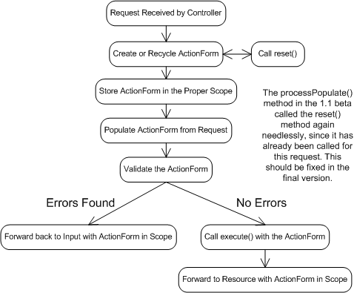
Figure 7-4. The Life Cycle of an ActionForm
All of the steps that a request goes through during request processing are not shown in Figure 7-4, only the ones that are relevant to an ActionForm. Notice that when an ActionForm detects one or more validation errors, it performs a forward back to the resource identified in the input attribute. The data that was sent in the request is left in the ActionForm so that it can be used to re-populate the HTML fields.

Creating an ActionForm
The ActionForm class provided by the Struts framework is abstract. You need to create subclasses of it to capture your application specific form data. Within your subclass, you should define a property for each field that you wish to capture from the HTML form. For example, suppose we want to capture the email and password fields from a form, similar to the one in Example 7-1. Example 7-2 illustrates the LoginForm for the Storefront application that can be used to store and validate the email and password fields.
Example 7-2. The LoginForm Stores the Email and Password Fields
package com.oreilly.struts.storefront.security;

import javax.servlet.http.HttpServletRequest;
import org.apache.struts.action.*;
/**
* Form bean for the user signon page.
*/
public class LoginForm extends ActionForm {
private String email = null;
private String password = null;

public void setEmail(String email) {
this.email = email;
}

public String getEmail() {
return (this.email);
}

public String getPassword() {
return (this.password);
}

public void setPassword(String password) {
this.password = password;
}

/**
* Validate the properties that have been sent from the HTTP request,
* and return an ActionErrors object that encapsulates any
* validation errors that have been found. If no errors are found, return
* an empty ActionErrors object.
*/
public ActionErrors validate(ActionMapping mapping, HttpServletRequest request){
ActionErrors errors = new ActionErrors();

if( getEmail() == null || getEmail().length() < 1 ){
errors.add("email", new ActionError("security.error.email.required"));
}
if( getPassword() == null || getPassword().length() < 1 ){
errors.add("password", new ActionError("security.error.password.required"));
}
return errors;
}

public void reset(ActionMapping mapping, HttpServletRequest request){
/** Because this ActionForm should be request scope, do nothing here because
* the fields will be reset when a new instance is created. We could
* have just not overrode the parent reset() method, but did so just
* to provide an example of the reset() method signature.
*/
}
}
When the form is submitted, an instance of the LoginForm will be created and populated from the request parameters. The framework does this by matching each request parameter name against the corresponding property name in the ActionForm class.
The ActionForm is populated from request parameters, not request attributes. If you are forwarding from one action to anther, you can’t add a request attribute and expect that the ActionForm will be populated from it. Request parameters and request attributes are two separate resources.

The ActionForm validate() Method
[Note: Brett, how should a method name like above be formatted in a heading 3?]
The validate() method may be called by the RequestProcessor for every request. Whether it’s called or not depends on two things. First, an ActionForm must be configured for an action mapping. This means that the name attribute for an action element must correspond to the name attribute of one of the form-bean elements in the configuration file.
The second condition that must be met before the RequestProcessor will invoke the validate() method is that the validate attribute must have a value of “true”. The following fragment shows an action element that uses the LoginForm from Example 7-2 and meets both requirements mentioned.
<action
path="/signin"
type="com.oreilly.struts.storefront.security.LoginAction"
scope="request"
name="loginForm"
validate="true"
input="/security/signin.jsp">
<forward name="Success" path="/index.jsp" redirect="true"/>
<forward name="Failure" path="/security/signin.jsp" redirect="true"/>
</action>
When the signin action is invoked, the framework will populate an instance of a LoginForm using values it finds in the request. Because the validate attribute has a value of “true”, the validate() method in the LoginForm will be called. Even if the validate attribute is set to “false”, the ActionForm will still be populated from the request if an ActionForm is configured for the action.
The validate() method in the base ActionForm class simply returns null. If you want to perform validation on the data that is submitted with the request, you’ll need to override the validate() method in your ActionForm subclasses, as in Example 7-2.
The validate() method may return an ActionErrors object, depending on whether or not any validation errors were detected. You also can return null if there are no errors; the framework will check for both null and an empty ActionErrors object. This saves you from having to create an instance of ActionErrors when there are no errors. The ActionErrors class and its parent class, ActionMessages, will be discussed later in this chapter.

The ActionForm reset() Method
The reset() method has been a bane for much of the Struts user community at one time or another. Exactly when the reset() method is called and what should be done within it is almost always misinterpreted. This doesn’t mean that one implementation is more correct than another, but there are misconceptions that many new Struts developers pick up and then have a hard time shaking regarding the reset().
As Figure 7-4 shows, the reset() method is called for each new request, regardless of the scope of the ActionForm. It’s called before the ActionForm has been populated from the request. The method was added to the ActionForm class originally to help facilitate resetting boolean properties back to their defaults. To understand why they need to be reset, it’s helpful to know how the browser and the HTML form submit operation processes checkboxes.
When an HTML form contains checkboxes, only the values for the checkboxes that are checked are sent in the request. Those that are not checked are not included as a request parameter. Therefore, the reset() method was added to allow applications to reset the boolean properties in the ActionForm back to false, since false wasn’t included in the request and the boolean values would possibly be stuck in the “true” state.
The reset() method in the base ActionForm contains no default behavior, since no properties are defined in this abstract class. Applications that extend the ActionForm class are allowed to override this method and reset the ActionForm properties to whatever state they wish. This may include setting boolean properties to true or false, setting String values to null or some initialized value, or even instantiating instances of other objects that the ActionForm holds on to. For an ActionForm that has been configured with request scope, the framework will essentially create a new instance for each new request. Since a new instance is created, there’s not much need to reset() the values back to any default state. ActionForms that are configured with session scope are different however. This is the time that the reset() method comes in handy.

Declaring ActionForms in the Struts Configuration File
Once you have created a class that extends ActionForm, you need to configure the class in the Struts configuration file. The first step is to add a new form-bean element to the form-beans section of the file:
<form-beans>
<form-bean
name="loginForm"
type="com.oreilly.struts.storefront.security.LoginForm"/>
</form-beans>
The value for the type field must be a fully qualified Java class name that is a descendant of ActionForm.
Once you have defined your form-bean, you can now use it in one or more action elements. It’s very common to share one ActionForm across several actions. For example, suppose there was an admin application that managed the items in the Storefront application. There would need to be an HTML form where a new item could be added to the system. This might be the createItem action. There would also need to be a getItemDetail action to show the details of an existing item. Both of these HTML forms would look similar, but maybe submit to a different action. Since the HTML forms contained the same properties, both of these could use the same ActionForm.
To use an ActionForm in an action element, you need to specify a few attributes for each action mapping that uses the ActionForm. These attributes are name, scope, and validate:
<action
path="/signin"
input="/security/signin.jsp"
name="loginForm"
scope="request"
type="com.oreilly.struts.storefront.security.LoginAction"
validate="true">
<forward name="Success" path="/index.jsp" redirect="true"/>
<forward name="Failure" path="/security/signin.jsp" redirect="true"/>
</action>
For more information on the attributes of the action element, see “The Struts Configuration DTD” in Chapter 4.

Using an ActionForm in an Action
Once you have configured the ActionForm for a particular Action, you can then insert and retrieve values from it within the execute() method, as Example 7-3 illustrates.
Example 7-3. The ActionForm is available within the execute() Method
public ActionForward execute( ActionMapping mapping,
ActionForm form,
HttpServletRequest request,
HttpServletResponse response )
throws Exception{

// Get the user's login name and password. They should have already
// validated by the ActionForm.
String email = ((LoginForm)form).getEmail();
String password = ((LoginForm)form).getPassword();

// Login through the security service
IStorefrontService serviceImpl = getStorefrontService();
UserView userView = serviceImpl.authenticate(email, password);

UserContainer existingContainer = null;
HttpSession session = request.getSession(false);
if ( session != null ){
existingContainer = getUserContainer(request);
session.invalidate();
}else{
existingContainer = new UserContainer();
}

// Create a new session for the user
session = request.getSession(true);
existingContainer.setUserView(userView);
session.setAttribute(IConstants.USER_CONTAINER_KEY, existingContainer);

return mapping.findForward(IConstants.SUCCESS_KEY);
}
It’s not mandatory that you always use an ActionForm to capture the data from an HTML form. Even if you don’t declare an ActionForm for a form, the data is still available from the request. However, your application will have to manually handle the process of validation and error handling from the Action class.

Declaring ActionForm Properties as Strings
All request parameters that are sent by the browser are Strings. This is true regardless of the type that the value will eventually map to in Java. For example, dates, times, Booleans, and other values are all strings when they are pulled out of the request. They will also be converted into strings when they are written back out to the HTML page. Therefore, it makes sense that all of the ActionForm properties where the input may be invalid, should be of type String. The reason for this is to support displaying the data back out in its original form to the user, when there is an error. For example, if a user types in “12Z” for a property expecting to be an Integer, there’s no way to store “12Z” into an int or Integer property. However, you can store it into a String until it can be validated. This same value, which is stored in a String, can be used to render the input field with the value, so the user can see their mistake. This is functionality that even the most inexperienced users have come to expect and look for.

Using ActionErrors
ActionForms are not the Model
Many developers get confused when they learn about the ActionForm class. Although it can hold state for an application, the state that it holds should be limited and constrained to the “user input” that is received from the client and should only hold it until it can be validated and transferred to the business tier.
You’ve already seen why it’s important to separate the model from the presentation tier in an application. Business objects can be persisted and should contain the business logic for an application. They should also be reusable. This set of criteria does not match up well when compared against ActionForms. For one thing, the ActionForm class is most certainly tied to the Struts framework and explicitly to a web container, since it imports javax.servlet packages. It would be very difficult to port ActionForm classes to a different type of framework, like a Swing application.
ActionForms are exclusively designed to capture the HTML data from a client, allow “presentation validation” to occur, and to provide a transport vehicle for the data back to the more persistent business tier. You will be well served to keep the ActionForms separate from your business components.
Earlier in the chapter, you saw that the validate() method returned an ActionErrors object. The ActionErrors class encapsulates one or more errors that have been discovered by the application. Each problem discovered is represented by an instance of org.apache.struts.action.ActionError.
An ActionErrors object has request scope. Once an instance is created and populated by the validate() method, it is stored into the request. Later, the JSP page can retrieve the object from the request and use the ActionError objects contained within it to display errors messages to the user.
The Struts framework includes a JSP custom tag that makes retrieving and displaying the errors messages very easy. This tag, called ErrorsTag, will be discussed in Chapter 8.
An instance of ActionErrors can be instantiated in the validate() method and populated by adding instances of the ActionError class to it. The LoginForm from Example 7-2 demonstrated this and is illustrated again here for convenience:
public ActionErrors validate(ActionMapping mapping, HttpServletRequest request){
ActionErrors errors = new ActionErrors();

if( getEmail() == null || getEmail().length() < 1 ){
errors.add("email", new ActionError("security.error.email.required"));
}

if( getPassword() == null || getPassword().length() < 1 ){
errors.add("password", new ActionError("security.error.password.required"));
}
return errors;
}
The validate() method in this fragment checks to make sure that the email and password fields have been set with values other than an empty string. If not, ActionError objects are added to the ActionErrors instance.
The ActionError class contains several useful constructors. Several are listed here:
public ActionError(String key);
public ActionError(String key, Object value0);
public ActionError(String key, Object value0, Object value1);
public ActionError(String key, Object[] values);
The key argument is a String value that corresponds to a key from one of the application’s resource bundles. The custom tag ErrorsTag uses this value to lookup the message to display to the user. The remaining arguments are used as parametric replacement values for the message. For example, if you had a bundle message defined like this:
global.error.login.requiredfield=The {0} field is required for login
then we could create an instance of an ActionError like this:
ActionError error = new ActionError("global.error.login.requiredfield", “Email” );
The message displayed to the user after substituting in the “Email” string would be:
The Email field is required for login
If building I18N applications is a requirement for you, you must be careful when using hard-coded string values as in the previous example. The String “Email” can’t be easily localized since it’s hard-coded into the source code.
In this case, you should also get the localized value from the bundle as well before passing it as an argument in ActionError constructor.
When adding instances of the ActionError class to the ActionErrors object, the first argument in the add() method is a property that can be used to retrieve a specific ActionError instance. If all of your ActionError instances can be treated the same and you have no need to retrieve them individually, you can use the constant ActionErrors.GLOBAL_ERROR similar to this:
errors.add(ActionErrors.GLOBAL_ERROR,
new ActionError("security.error.password.required"));

The ActionMessage Class
Starting with Struts 1.1, a new message class has been added that can also be used to display messages to a user. The org.apache.struts.action.ActionMessage class operates in the same manner that the ActionError class does, in fact, it’s been added as the super class to the ActionError class.
The main reason that the ActionMessage class was added to the framework was that the name ActionError implies that it shouldn’t be used for general purpose informational or warning types of messages, although it is used that way by many developers. A more general-purpose message class made sense.
The ActionMessage is used exactly like the ActionError class, except that it can represent a less severe message that needs to be displayed to the user. Instances of this class are created the same way and added to an ActionMessages object, instead of an ActionErrors object. Because ActionError is just a specialized message, it extends the ActionMessage class. In fact, the ActionErrors class also extends the ActionMessages class. Figure 7-5 illustrates the relationship between these classes.
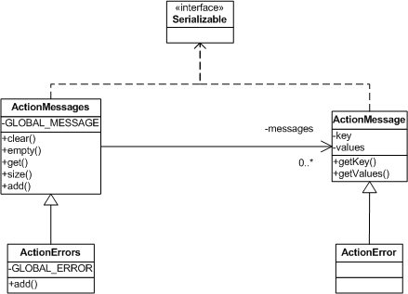
Figure 7-5. ActionErrors are Specialized ActionMessages

Creating ActionErrors in the Action Class
The ActionForm is not the only place that you can create ActionMessages or ActionErrors. You may also create them in other parts of the framework. If for example, a business operation called from an Action raised an exception and you wanted to insert an error message informing the user, you can create ActionErrors from the Action class itself. The Struts Action class includes functionality to help support this.
When the business operation throws the exception, the Action class will catch it and take the appropriate steps. This is usually to return to the previous page and display an error message to the user. Returning to the previous state can be accomplished by returning the appropriate ActionForward, but the ActionError needs to be put in the request before the forward occurs.
In Chapter 10 Exception Handling, you’ll learn how to take advantage of the new declarative exception handling and thus avoid having to deal with the exceptions in the Action class completely.
Example 7-4 illustrates how this is done within the LoginAction class.
Example 7-4. Creating ActionErrors from the execute() Method
public ActionForward execute( ActionMapping mapping,
ActionForm form,
HttpServletRequest request,
HttpServletResponse response )
throws Exception{

/**
* Get the user's email and password, which should have already been
* validated by the ActionForm.
*/
String email = ((LoginForm)form).getEmail();
String password = ((LoginForm)form).getPassword();

// Login through the security service
IStorefrontService serviceImpl = getStorefrontService();

UserView userView = null;
try{
userView = serviceImpl.authenticate(email, password);
}catch( InvalidLoginException ex ){
ActionErrors errors = new ActionErrors();
ActionError newError = new ActionError( "security.login.failed" );
errors.add( ActionErrors.GLOBAL_ERROR, newError );
saveErrors( request, errors );
// Return back to the previous state
return mapping.findForward( mapping.getInput() );
}

// Authenticate was successful
UserContainer existingContainer = null;
HttpSession session = request.getSession(false);
if ( session != null ){
existingContainer = getUserContainer(request);
session.invalidate();
}else{
existingContainer = new UserContainer();
}

// Create a new session for the user
session = request.getSession(true);
existingContainer.setUserView(userView);
session.setAttribute(IConstants.USER_CONTAINER_KEY, existingContainer);

return mapping.findForward(IConstants.SUCCESS_KEY);
}
}
In Example 7-4, when an InvalidLoginException is thrown by the authenticate() method, the exception is caught and an ActionError is created. The saveErrors() method exists in the Struts base Action class and stores the ActionErrors object into the request. A corresponding saveMessages() method also exists for a similar purpose.
Once the ActionErrors or ActionMessages is stored in the request and control is forwarded to a JSP page, the framework includes several JSP custom tags for printing out the messages to the user. These will be discussed in the next chapter.

Performing Presentation Validation
This chapter has touched on performing your application’s input validation in the validate() method of the ActionForm. You can create whatever presentation validation rules you need in this method. For example, the LoginForm from Example 7-2 validated that the email and password fields were entered and they were not empty strings. Although this is trivial example, you have the freedom to validate anything that you would like. A very common validation rule is to ensure that a string value that should be a number is in fact a string representation of a valid number. The validate routine for this rule might look like the one in Example 7-5.
Example 7-5. Performing a Number Validation Rule
public ActionErrors validate(ActionMapping mapping, HttpServletRequest request) {
ActionErrors errors = new ActionErrors();

String orderQtyStr = getQuantity();

if( orderQtyStr == null || orderQtyStr.length() < 1 ){
errors.add( ActionErrors.GLOBAL_ERROR,
new ActionError( "order.quantity.required" ));
}

// Validate that the qty entered was in fact a number
try{
// Integer.parse was not used because it's not really I18N safe
java.text.Format format = java.text.NumberFormat.getNumberInstance();
Number orderQty = (Number)format.parseObject( orderQtyStr );
}catch( Exception ex ){
// The Quantity entered by the user was not a valid qty
errors.add( ActionErrors.GLOBAL_ERROR,
new ActionError( "order.quantity.invalid" ));
}
return errors;
}
As you can imagine, checking for required values or validating that data entered fits a certain format or is of a certain type, is done quite often in web applications. Since all data that is retrieved from a request is of type String, you must ensure that the data is not going to corrupt your business components.
Although you can perform the validation programmatically, the Struts framework provides an alternative that can be external to the ActionForm and validate() method. In fact, for most of the standard validation rules, you don’t have to write a line of code because the rules are already defined. All you need to do is to declaratively configure the rules that you need in an extra XML file. The Struts Validator will be covered in Chapter 11.

Using Dynamic ActionForms
Using the ActionForm class has many advantages over performing the functionality yourself in the Action class or some set of helper utility classes. Since the behavior that the ActionForm class provides is needed in nearly every web application, as well as many times in the same application, using the framework to perform the work can really reduce the development time and your frustration level. Having stated the benefits of using ActionForms, there are a few very important downsides to using them.
The first and foremost problem with using ActionForms is the sheer number of classes that it can add to a project. Even if you share ActionForm definitions across many pages, the additional classes make it more difficult to manage a project and provide maintenance. This is why some developers might create a single ActionForm and implement the properties for all of the HTML forms within these. The problem with this of course, is that combining the fields into this one class makes it a point of contention on a project that has more than just a few developers.
Another major liability is the requirement to define the properties in the ActionForm that need to be captured from the HTML form. If a property is added or removed from the HTML form, the ActionForm class may need to be modified and recompiled.
For these reasons, a new type of ActionForm was added to the framework, which is dynamic in nature and allows you to avoid having to create concrete ActionForm classes for your application. The dynamic ActionForm is implemented by the base class org.apache.struts.action.DynaActionForm, which extends the ActionForm class. There are only three real differences among all ActionForms for any application:
- The properties that the ActionForm defines
- The validate() method
- The reset() method
The properties for a DynaActionForm are configured in the Struts configuration file, which you’ll see how to do in the next section. The reset() method is called at exactly the same time during request processing as it is for a standard ActionForm. The one difference is that you have a little less control over what you do during the method. However, you can always subclass the DynaActionForm to override the reset behavior.
The validation of the presentation data is a little more complicated, because we’ll need to wait until we talk about the Struts Validator components before talking about how validation occurs in a dynamic form.

Configuring Dynamic ActionForms
To use the DynaActionForm in your Struts application, the first step is to add a form-bean element to the configuration file. There are two very important differences between a form-bean element for a regular ActionForm and one that is dynamic.
First, a form-bean element for a dynamic ActionForm is required to have an attribute called dynamic, which must have a value of “true”. This is necessary for the framework to understand that it should handle this ActionForm differently. The second difference is that you must include one or more form-property elements in order for the dynamic form to have properties. The DynaActionForm uses a java.util.Map internally to store key/value pairs. The form-property elements are loaded into the Map and become the properties that get populated by the framework.
The attributes for the form-bean and form-property are discussed in more detail in Chapter 4.
Example 7-5. A Dynamic ActionForm must be specified in the Struts Configuration File
<form-beans>
<form-bean
name="loginForm"
dynamic="true"
type="org.apache.struts.action.DynaActionForm">

<!-- Specify the dynamic properties of the form -->
<form-property
name="email"
type="java.lang.String "/>
<form-property
name="password"
type="java.lang.String "/>

<!-- You can also set the initial value of a property -->
<form-property
initial=”false”
name="rememberMe"
type="java.lang.Boolean "/>
</form-bean>
<form-beans>
The declarative properties are what make the ActionForm dynamic. At runtime, the framework creates an instance of the DynaActionForm class and makes it possible to set and get the configured property values. To add new properties, you only need to modify the configuration file. No source code needs to be changed. The power and flexibility that this provides for you is immense.
As Chapter 4 outlined, the form-beam element also allows you to specify the initial value for each property. The framework will set the property to that value when the application is started. The initial value is also used when the reset() method is called to reset the values back to their original state. If you don’t include the initial attribute, then properties will be assigned default values based on the Java programming language; numbers to zero (0) and properties of type Object will be assigned a null value by the framework.
The type attribute expects a fully qualified Java class name. Therefore, you will need to use the wrapper classes for primitives. For example, java.lang.Boolean for a boolean property type, java.lang.Integer for an int property, and so on.

Performing Validation using Dynamic ActionForms
Since the DynaActionForm is used for every dynamic ActionForm and you don’t provide subclasses of ActionForm, there’s no way to override the validate() method. Fortunately, the framework comes to your aid again with a feature called the Struts Validator.
The Struts Validator was created by David Winterfeldt and is now in the main Struts distribution. The validator is a framework that was intended to work with Struts from the beginning. It supports basic validation rules like checking for required fields, email, date and time fields, and many others. One of the biggest benefits is that it provides many of the validation rules that web applications need to perform. It is also very easy to add your own validator; this will be covered in Chapter 11.

Looking Ahead to JavaServer Faces
JavaServer Faces (JSF) is designed to provide a standard set of JSP tags and Java classes, which will make it easier to build Java server application GUIs. The problem that’s being addresses with this technology is when creating web applications; the Servlet and JSP technologies don’t provide specific enough APIs for creating the client GUI. Developers have to rely on HTML components and one of several alternatives to facilitate style and behavioral changes to all of the views. The mechanism to manage all of this eventually takes on a life of its own and overshadows the business of the application. Instead of performing maintenance on business operations and logic, more and more time is needed to manage the presentation widgets.
JSF plans to fix this by creating a standard way to define complex HTML forms and other GUI elements. This will enable developers to focus their attention on a single component framework.
The first release of the framework includes the following design goals:
- Create a standard GUI component framework, which can be leveraged by development tools to make it easier for tool users to both create high quality GUIs and manage the GUI's connections to application behavior.
- Define a set of simple lightweight Java base classes for GUI components, component state, and input events. These classes will address GUI lifecycle issues, notably managing a component's persistent state for the lifetime of its page.
- Provide a set of common GUI components, including the standard HTML form input elements. These components will be derived from the simple set of base classes (outlined in #1) that can be used to define new components.
- Provide a JavaBeans model for dispatching events from client-side GUI controls to server-side application behavior.
- Define APIs for input validation, including support for client-side validation.
- Specify a model for internationalization and localization of the GUI.
- Automatic generation of appropriate output for the target client, taking into account all available client configuration data, such as browser version, etc.
- Automatic Generation of output containing required hooks for supporting accessibility, as defined by WAI.

What does JSF have to do with Struts?
JSF and Struts will fit together quite well, as developers will eventually be able to supplement or substitute the Struts custom tag libraries with JSF components. The rest of the Struts framework, both model and controller components will remain relatively unaffected by the JSF architecture.
JSF will also include an event model, but the architecture will be designed so that developers can choose to use the GUI components with or without the event mechanism.
Because there is no public specification for JSF currently, it’s hard to be specific on exactly how the two will tie into each other. However, Craig McClanahan who is the founder of the Struts framework is also now the specification lead for the JavaServer Faces JSR. This means that we can look closely at Craig’s comments on JSF and Struts and know that he is speaking with subject matter expertise.
You can find the JavaServer Faces JSR at http://jcp.org/jsr/detail/127.jsp.

[Note: Add a note in here about how the regular ActionForm reset() doesn’t do anything, but the dynamic one actually resets everything. This may cause a change upgrading to them and you might need to extend and override the reset().]

See: http://www.mail-archive.com/struts-user@jakarta.apache.org/msg30062.html

